St Christophers Playgroup
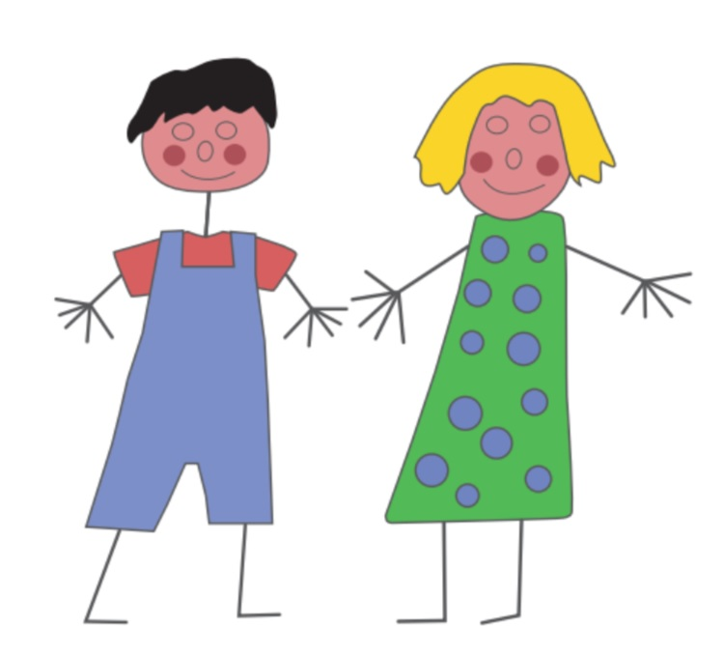

Charity No. 1053824

St Christopher’s Church Halls
1 Lincoln Avenue
Warden Hill
Cheltenham
Telephone: 07914 740022
Email: info@stchristophersplaygroup.uk
Website: www.stchristophers.uk

Gloucestershire
GL51 3DD

APPLICATION FORM

Child’s name: ______________________ Age ____ Child’s Date of Birth: __________________

Address: _______________________________ Telephone Numbers: Home: _________________

_______________________________________ Mobile: ________________

_______________________________________

Postcode: ______________________________ Email:___________________________________

Does your child attend any other setting? e.g. Playgroup/nursery/childminder Yes/No

If YES which one(s)? _______________________________________________________________

Which sessions do you wish your child to attend? Please circle below.
Monday  9am-12pm 9am-1pm  9am-3pm | Tuesday  9am-12pm 9am-1pm  9am-3pm | Wednesday  9am-12pm 9am-1pm  9am-3pm | Thursday  9am-12pm 9am-1pm  9am-3pm | Friday  9am-12pm 9am-1pm  9am-3pm
We will endeavor to provide the sessions you have requested but may have to offer an alternative if we are already full on those days.

Does your child have Special Needs or allergies? Yes/No

If Yes give details: __________________________________________________________________

_________________________________________________________________________________

Is there anything else playgroup staff need to know about your child? __________________________

_________________________________________________________________________________

Signed: __________________________________ Date: ____________________________

*Once a place is offered you will be required to pay an administration fee of £15 this will include a polo shirt for your child when they start. This can be paid in cash on their settling in visit or can be added to your first invoice. We will contact you as soon as this form has been processed.

Staff Only

Signed:_________________________________________ Date received:______________________

All children are entitled to 15 hour’s free government funding starting the term after their 3rd birthday. Some children are eligible from 2 years old, or eligible for 30 hours free funding per week. Please check at www.childcarechoices.gov.uk

